

WEB STARS

LENYORA PRIMARY SCHOOL DIGITAL APPLICATION SYSTEM

Initial Software Requirements Specifications (SRS)
Submitted to:
Mr. T. Mokoduwe
Department of Information Technology
In Partial Fulfilment of the Requirements for
Work Integrated Learning (WIL)
Submission Date: 26 August 2026

GROUP MEMBERS
Student Number | Full Name | Role
222020350 | SM Nkosi | Project Lead / Backend Developer
222002417 | L Kayane | Mobile App Developer (Flutter)
223028212 | GD Sekhula | Database Designer (Supabase) / Tester
222040802 | TH Mosia | Frontend Developer / UI/UX Designer
216009568 | MN Matla | Web Portal Developer (ASP.NET)
Supervisor: Mr. T. Mokoduwe
Client Representative: Principal, Lenyora Primary School

TABLE OF CONTENTS
- Introduction
o 1.1 Project Title o 1.2 Problem Statement o 1.3 Purpose, Aim and Objectives
- Project Scope o 2.1 Scope Definition o 2.2 Deliverables and Acceptance Criteria o 2.3 Exclusions, Constraints and Assumptions
- Stakeholders and User Groups
- Current Process and Proposed Process
- Product Perspective
- Main Flutter, ASP.NET and Supabase Functions
- Functional Requirements
- Non-Functional Requirements
- System Requirements
- Integration Requirements
- Requirements Prioritisation
- Appendices

1. INTRODUCTION
1.1 Project Title
Lenyora Primary School Digital Application System

1.2 Problem Statement
Lenyora Primary School currently relies on fragmented manual processes to manage learner applications and communicate subject information to parents. School announcements are shared through physical notice boards and WhatsApp groups, subject listings are provided verbally or through printed handouts, and learner applications are collected and submitted using paper forms. This outdated approach creates significant challenges:
- Communication Gaps: Parents frequently miss important announcements due to the limitations of notice boards and the chaotic nature of WhatsApp group messages.
- Lack of Transparency: There is no centralized, accessible source for parents to view the subjects offered per grade, leading to confusion and misinformation.
- Administrative Inefficiency: School staff spend excessive time managing paperwork, manually tracking applications, and responding to repetitive parent inquiries.
- Lost or Damaged Forms: Paper application forms are often lost, misplaced, or damaged, causing frustration for parents and delays in the enrollment process.
- No Digital Presence: The school lacks a centralized digital platform where parents can reliably access information and complete applications online.
These challenges underscore the urgent need for a comprehensive digital solution that modernizes communication and application management at Lenyora Primary School.

1.3 Purpose, Aim and Objectives
Purpose
To develop a centralized digital system for Lenyora Primary School that digitizes all aspects of application announcements, subject information dissemination, and learner application submission and management.
Aim
To build a cross-platform Flutter mobile application for parents and a secure ASP.NET Core web portal for school administrators, both integrated with a robust and scalable Supabase backend.
Objectives
- To enable parents to view school announcements in real-time, including application opening and closing dates.
- To allow parents to view accurate and up-to-date subject listings organized by grade.
- To provide parents with an intuitive online form to apply for their children's enrollment.
- To empower school administrators to efficiently manage announcements, subjects, and applications from a single web-based dashboard.
- To ensure all system data is stored securely, reliably, and access-controlled using Supabase's PostgreSQL database and authentication services.
- To improve the overall user experience for parents, especially those with limited digital literacy, through a simple and user-friendly interface design.

2. PROJECT SCOPE
2.1 Scope Definition
In Scope:
Component | Description
Mobile Application | A cross-platform Flutter application for parents/guardians, supporting Android 8.0 and above.
Admin Web Portal | An ASP.NET Core MVC/Web API application accessible via modern web browsers.
Backend Infrastructure | Supabase for authentication, PostgreSQL database, and file storage.
User Authentication | Secure registration and login for both parents and school administrators.
Announcements Module | Admin CRUD operations; real-time viewing for parents on the app.
Subject Listing Module | Admin management of subjects per grade; parent viewing by grade.
Online Application Module  Application Status | Parents can submit learner applications with required details and document uploads.
Tracking  Out of Scope: | Parents can check application status; admin can approve or reject applications.
Feature | Reason
Online School Fees Payment | Planned for a future phase; not required for initial deployment.
Learner Results Management | Academic records management is not part of the current phase.
SMS or Email Notifications | Notifications will be delivered through in-app announcements.
iOS App Publishing | The Flutter app will be built for Android only during this phase.

2.2 Deliverables and Acceptance Criteria
Deliverables
- Initial SRS Document: This completed Software Requirements Specifications document.
- Flutter Mobile Application: An installable Android APK file that can be distributed to parents.
- ASP.NET Admin Website: A fully functional, deployable web application for school
administrators.

- Supabase Database Setup: A configured Supabase project with defined tables, relationships, security policies (Row Level Security), and storage buckets.
# | Criterion
AC1 | Parents must be able to register, log in, and successfully submit a learner application with all required fields and document uploads.
AC2 | When an admin creates or updates an announcement, it must appear on the parent app within 2 seconds (real-time sync).
AC3  AC4 | An admin must be able to add, edit, and delete subjects and assign them to specific grades.  All submitted applications must be stored in Supabase and be immediately viewable, searchable, and
Acceptance Criteria
manageable by the admin on the web portal.

2.3 Exclusions, Constraints and Assumptions
Exclusions
- No payment gateway integration.
- No SMS or email notification services.
- No iOS app publishing (Android only).
- No integration with third-party school management systems.
Constraints
- Technology Stack: The project must be built using Flutter for the mobile app, ASP.NET Core (MVC/Web API) for the web portal, and Supabase as the backend.
- Platform Support: The mobile app must run on Android 8.0+. The admin portal must be compatible with the latest Chrome and Edge browsers.
- Timeline: The initial SRS must be submitted by 25 August 2026; project delivery expected by the end of the semester.
Assumptions
3. STAKEHOLDERS AND USER GROUPS
Role | Description | Key Responsibilities/Interests
Primary  Stakeholder | Principal / Administrator of  Lenyora Primary School | Overall approval, providing school data, and ensuring the system meets school needs.
Parent/Guardian | Primary end-user of the Flutter app | View announcements and subjects; apply for child; track application status.
School Admin | School staff managing the system | Manage announcements; manage subjects; review, approve/reject applications.
Guest | Unauthenticated website  visitor | View general school information (name, contact, grade list) without login.
Development  Team | Students and project supervisor | Design, develop, test, and deploy the system.
- Parents/guardians have access to smartphones with a stable internet connection.
- The school has a dedicated PC with a reliable internet connection for administrative use.
- The stakeholder (Principal/Admin) will provide all official school information (grade structure, subject lists, application dates) within the stipulated time.
- The school will designate a staff member to be the primary system administrator.
- Users have basic literacy in English to navigate the application.

4. CURRENT PROCESS AND PROPOSED PROCESS

4.1 Current Process (As-Is)
The following flowchart illustrates the current manual process:
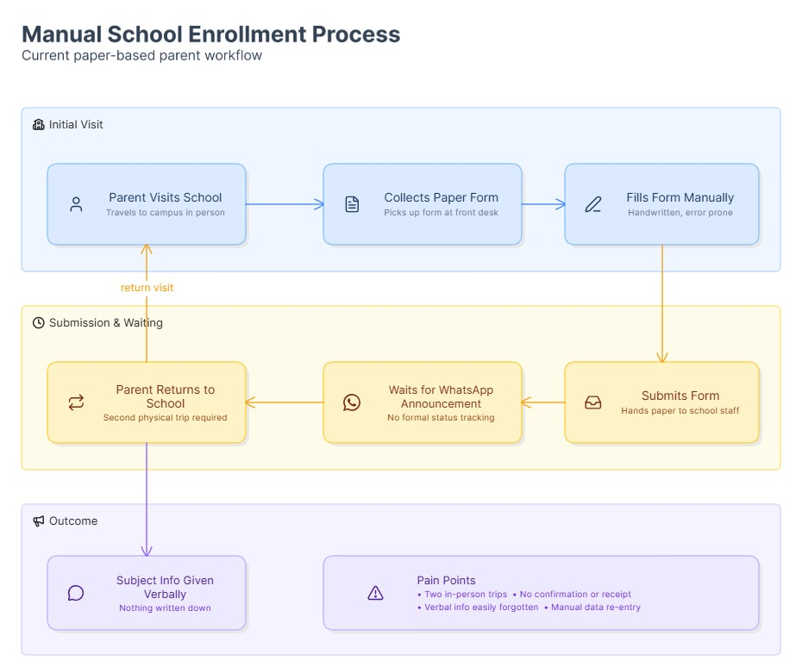
Detailed Steps:
- Parent visits the school campus to inquire about admissions.
- Parent collects a paper application form from the administrative office.
- Parent manually fills out the form and gathers required physical documents (ID, birth certificate).
- Parent returns to the school to submit the completed form and documents.
- Staff processes the paperwork manually.
- Parent waits for a WhatsApp message or notice board announcement regarding the application outcome.
- Subject information is provided verbally or through printed handouts.

4.2 Proposed Process (To-Be)
The following flowchart illustrates the proposed digital process:
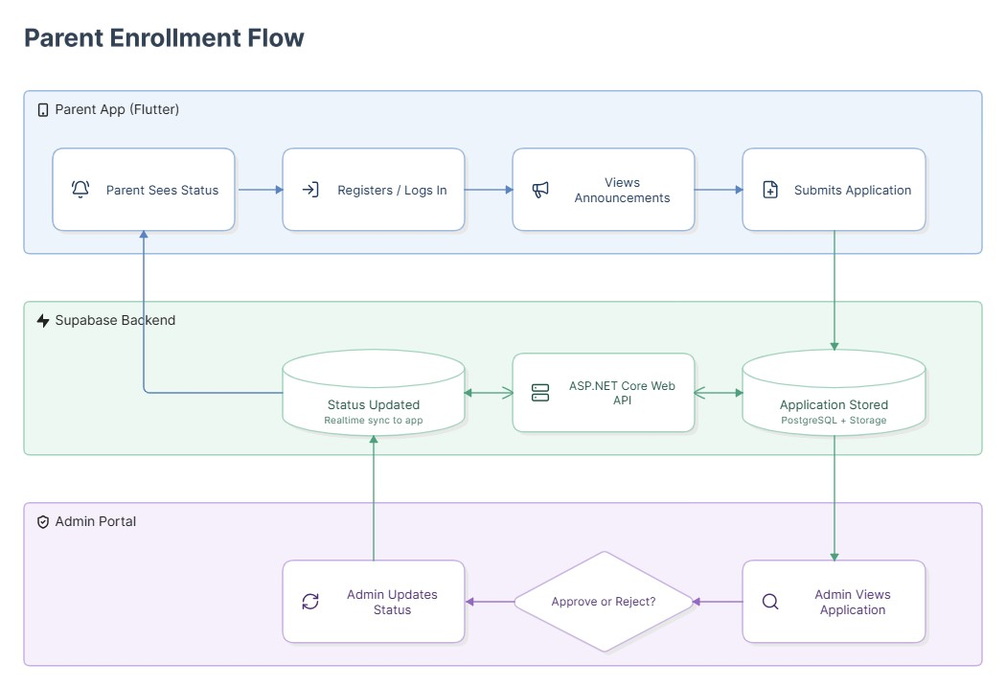
Detailed Steps:
- Parent opens the Lenyora Primary School Flutter application.
- Parent registers and logs into the application.
- Parent views current announcements, including application opening and closing dates.
- Parent browses subject listings per grade.
- Parent fills out the digital application form and uploads required documents (e.g., ID, birth certificate).
- Parent submits the application; data is stored in Supabase.
- Admin is notified of the new application on the ASP.NET web portal.
- Admin reviews the application details and documents.
- Admin approves or rejects the application, updating its status.
- Parent opens the app, navigates to the status tracker, and sees the updated status (Pending/Approved/Rejected).

5. PRODUCT PERSPECTIVE
This system is a new, standalone solution designed to replace the school's current manual processes. It is a greenfield project with a modern, cloud-based architecture to ensure scalability, security, and maintainability.

System Architecture Diagram
text
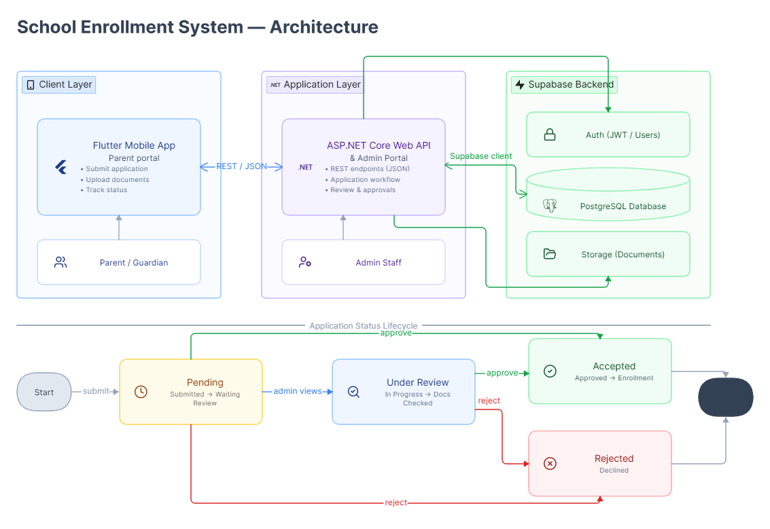

Key Layers
- Presentation Layer:
  - Flutter App: Provides the user interface for parents, offering a clean and intuitive mobile experience.
  - ASP.NET Admin Portal: Provides a responsive web interface for school administrators to manage the system.
- Business Logic Layer:
  - ASP.NET Web API: Handles core business logic, data validation, and API endpoints consumed by the Flutter app.
- Data Layer:
  - Supabase: Acts as the primary data store, providing authentication, PostgreSQL database, and file storage with robust security features.

6. MAIN FLUTTER, ASP.NET AND SUPABASE FUNCTIONS

6.1 Flutter (Mobile Application)
Function Description
Parent
Secure sign-up and sign-in using Supabase Auth.
Registration/Login
Display a list of announcements with real-time updates. Show opening and closing View Announcements

dates.
View Subject Listings Display subjects organized by grade.

Provide a multi-step form for entering child details (Name, Age, Grade) and parent
Apply for Child | details. Allow document uploads (ID, birth certificate).
Track Application  Status | Display status of submitted applications (Pending/Approved/Rejected) in a userfriendly format.

6.2 ASP.NET Core (Web API & Admin Portal)
Function | Description
Admin Authentication | Secure login for authorized school administrators.
Manage Subjects (CRUD)  Manage Announcements | Add, edit, delete, and assign subjects to grades.
(CRUD) | Create, update, delete, and schedule announcements.
View Applications | Display all applications with detailed information.
Approve/Reject Applications | Change application status with an option to add notes/comments.
Admin Dashboard | Display key metrics and statistics (e.g., total applications, pending approvals).
API Endpoints | Expose RESTful APIs for the Flutter app to consume.
Function | Description
Authentication | Manage user sessions and JWT tokens for parents and admins.
PostgreSQL Database | Store and manage data in tables: users, announcements, subjects, applications.
Row Level Security (RLS) | Enforce data access policies to ensure users only see their own data.
Storage Buckets | Store uploaded documents (ID, birth certificates) securely.
Real-time Subscriptions | Enable instant updates of announcements on the Flutter app.

6.3 Supabase (Backend)

7. FUNCTIONAL REQUIREMENTS
ID | Requirement | Priority
FR1 | The system shall allow parents/guardians to register and log in securely using email and password. | Must Hav
FR2 | The system shall allow an admin to create, update, and delete announcements. | Must Hav
FR3 | The system shall display announcements on the parent app in real-time (within 2 seconds). | Must Hav
FR4 | The system shall allow an admin to manage subject listings (add, edit, delete) per grade. | Must Hav
FR5 | The system shall allow parents to view subject listings filtered by grade. | Must Hav
FR6 | The system shall allow a parent to submit a learner application with required details (Child Name, Age, Grade, Parent Details) and upload documents. | Must Hav
FR7 | The system shall allow a parent to view the status of their submitted applications (Pending/Accepted/Rejected). | Should  Have
FR8 | The system shall allow an admin to view, search, filter, and approve/reject applications. | Must Hav
FR9 | The system shall allow an admin to search and filter applications by status, grade, and applicant name. | Should  Have
FR10 | The system shall validate required form fields before submission. | Must Hav
FR11 | The system shall display appropriate error messages for failed operations (e.g., login failure). | Must Hav

8. NON-FUNCTIONAL REQUIREMENTS

ID | Requirement | Detail
NFR1 (Performance) | The app and website should load in < 3 seconds on a standard internet connection. | High priority for user satisfaction.
NFR2 (Security) | Passwords must be encrypted (hashed). Supabase Row Level Security must be enforced. Only admins can delete data. | Critical for data protection.
NFR3 (Usability) | The interface must be simple and intuitive, usable by parents with low digital literacy. Clear labels and guided workflows. | Essential for adoptio
NFR4 (Availability) | System should be available 99% of the time during school hours (8 AM – 4 PM). | Critical for continuou service.
NFR5 (Scalability) | System should handle up to 500 concurrent parent users during peak application season. | Ensures smooth performance.
NFR6 (Maintainability) | Code should be well-documented and follow standard coding conventions for easy maintenance. | Important for future development.
NFR7 (Mobile  Responsiveness) | The admin portal should be responsive and accessible on different screen sizes. | For flexibility of admin access.

9. SYSTEM REQUIREMENTS

9.1 Software Requirements
Component | Technology
Mobile App | Flutter 3.22+ (or latest stable version)
Admin Portal/API | .NET 8 (ASP.NET Core MVC and Web API)
Component |  | Technology
Backend |  | Supabase (latest stable version)
Mobile OS |  | Android 8.0 (API level 26) and above
Admin Web Browser |  | Latest Google Chrome / Microsoft Edge

9.2 Hardware Requirements
User Minimum Specification
Android smartphone with 2GB RAM, 16GB storage, and a camera (for document
Parent (Mobile)
scanning).
School Admin
PC with 4GB RAM, 1GHz processor, and a 10Mbps internet connection.
Integration Point | Description
Flutter App  ↔ ASP.NET Web API | The Flutter mobile app will communicate with the backend through REST APIs (JSON format) hosted on the ASP.NET Web API.
ASP.NET API ↔  Supabase | The ASP.NET API will use the official Supabase Client library for .NET to interact with the database, authentication, and storage.
(PC)

9.3 Network Requirements
- A stable internet connection is required for both the mobile app and the web portal.
- The mobile app should handle offline scenarios gracefully (e.g., show cached data and notify user of network loss).

10. INTEGRATION REQUIREMENTS
validate requests using Supabase JWT tokens.

Integration Point | Description
Flutter App ↔ Supabase | The Flutter app will use the Supabase Flutter client for direct authentication (login/register) and real-time subscriptions for announcements.
Flutter App ↔ Supabase  Storage  Authentication Flow | The Flutter app will upload application documents directly to the Supabase Storage bucket.  Supabase Auth will manage authentication. The Flutter app and ASP.NET API wi
Priority | Requirement
Must  Have | Parent Registration/Login; View Announcements; View Subjects per Grade; Apply for Child; Admin Manage Applications; Admin Manage Announcements.
Should  Have | Document Upload for Applications; Application Status Tracking; Search and Filter Applications (Admin).
Could  Have  Won't  Have | Push Notifications for new announcements; Download Application as PDF; Email notifications for status updates.  Online Fees Payment; Chat with Teacher functionality; iOS App publishing.

11. REQUIREMENTS PRIORITISATION (MoSCoW)

12. APPENDICES

Appendix A: Letter of Agreement with Lenyora Primary School Principal
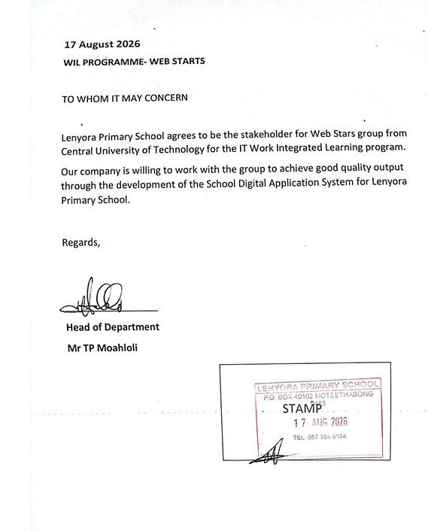

Appendix B: Stakeholder Communication Evidence
Meeting Summary
Date: 24 August 2026
Attendees: Project Team, Principal of Lenyora Primary School Location: Lenyora Primary School, Administration Office Key Points Discussed:
- Confirmed the need for a mobile application for parents and a web portal for the school.
- Discussed current challenges with paper-based applications and communication.
- Agreed on key system features (announcements, subjects, applications).
- Identified primary users and their needs.
- Principal provided initial school data (grade structure, subject lists).
- Signed a letter of agreement for the project.
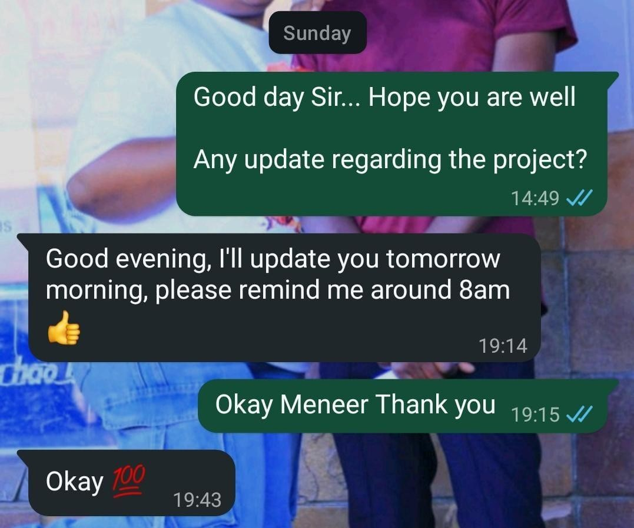

Appendix C: Interview Notes
Interview with: Principal, Lenyora Primary School
Date: 24 August 2026
Key Requirements Identified:
- "We need a way to communicate with parents instantly and reliably."
- "Parents often ask which subjects are offered in each grade. We need to make this easily accessible."
- "The application process is too manual. We lose forms and parents lose forms. We need a digital solution."
- "It would be helpful to see all applications in one place and easily track them."
- "We want to be able to update application status and have parents see it immediately."
- "The app should be simple to use. Many parents are not very familiar with technology."
- "We need the system to be affordable and easy to maintain."

Appendix D: GitHub Repository
The project source code is hosted on GitHub and can be accessed at the following link:
GitHub Repository:

L
https://github.com/hlonikayane/SCHOO
-
DIGITA
L
-
APPLICATIO
N
-
SYSTEM.gi
t

Appendix E: Supabase Database Screenshot
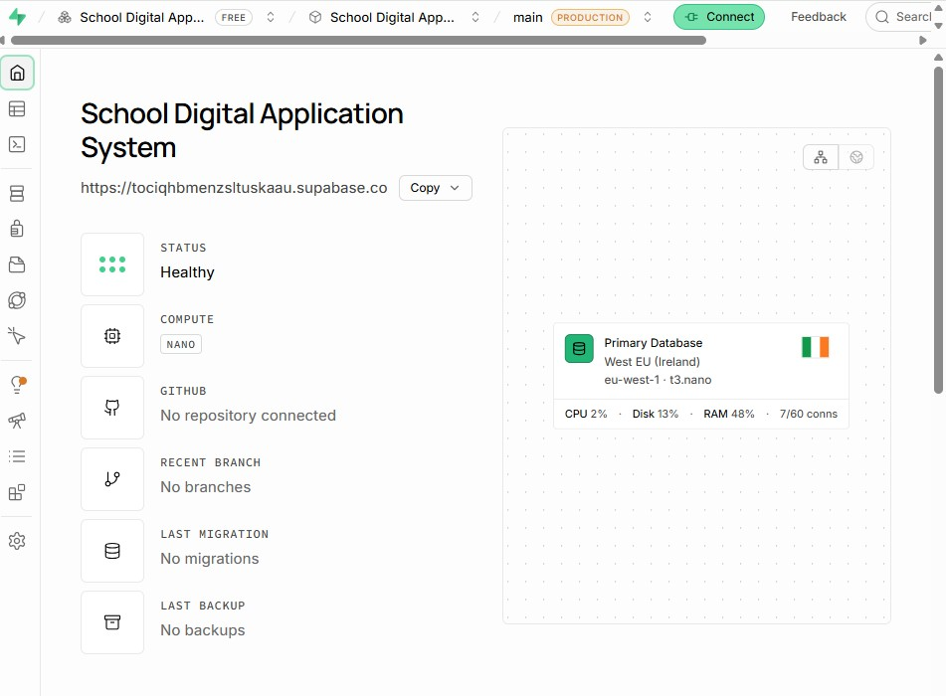
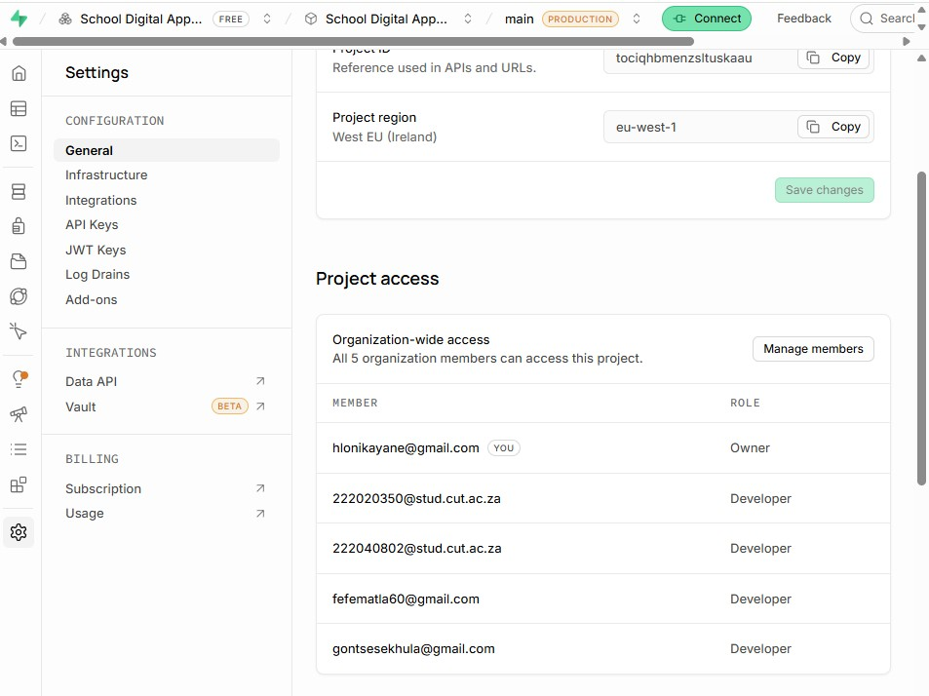
Term | Definition
SRS  Flutter | Software Requirements Specifications  Google's open-source UI toolkit for building natively compiled applications

Appendix F: Glossary of Terms
across mobile, web, and desktop from a single codebase.
A cross-platform, high-performance framework by Microsoft for building
ASP.NET Core modern, cloud-based, Internet-connected applications.
An open-source Firebase alternative that provides a PostgreSQL database,
Supabase authentication, storage, and real-time capabilities.

Term | Definition
API (Application  Programming Interface) | A set of rules and protocols for building and interacting with software applications.
REST (Representational State  Transfer) | An architectural style for designing networked applications, relying on stateless, client-server communication, typically over HTTP.
JWT (JSON Web Token)  CRUD (Create, Read, Update, | A compact, URL-safe token used for securely transmitting information between parties.
Delete) | The four basic operations for persistent storage.
Row Level Security (RLS) | A database security feature that restricts access to rows in a table based on the user executing a query.
MoSCoW | A prioritization technique: Must Have, Should Have, Could Have, Won't Hav

REVIEWING CURRENT PROJECT

Question | Group response
What is the main problem being addressed? | Lenyora Primary School's manual, paper-based processes for learner applications and communication are inefficient, leading to lost forms, communication gaps, and administrative burden.
What are the main Flutter functions? | Parent registration/login, viewing announcements, submitting learner applications, and tracking application status.
What are the main ASP.NET functions? | Admin authentication, managing announcements (CRUD), viewing applications, and approving/rejecting applications.
What information will Supabase manage? | User authentication data, announcements, applications, and uploaded documents (e.g., IDs, birth certificates).
Which functions appear most difficult? | Real-time announcement updates, secure document uploads, and building a simple, intuitive UI for users with low digital literacy.
Which functions require skills the group still needs to develop? | Skills in Flutter, ASP.NET Core, and Supabase are being learned concurrently with the project.
Which functions may require more time than is available? | Building a fully polished, well oiled production-ready mobile app and a website with all 'Must Have' and 'Should Have' features within the semester.

TECHNICAL FEASIBILITY

Question | Group finding
Does the group have the required Flutter skills? | Yes
Does the group have the required ASP.NET skills? | Yes
Can the group work with Supabase? | Yes
Can Flutter and ASP.NET connect to the same Supabase backend? | Yes
Are suitable development computers available? | Yes, each member has a personal computer suitable for the development
Are suitable test devices available? | Yes, the group members have android smart phones for testing
Is reliable internet access available? | Yes, all members have reliable internet access at their rooms and in campus
Which technical skills still need to be learned? | Practical skills in Flutter (UI, state management and API) ASP.NET (MVC, API, Integration Supabase), Supabase (Database design)
Which functions may be too technically difficult? | Implementing secure documents may be challenging

Technical Feasibility Decision:
Feasible with changes.
Explanation for the decision:
We are going to allocate significant time to finish the project.

Operational Feasibility

Question | Group finding
Will the prototype address the stakeholder's problem? | Yes
Who will use the mobile application? | Learner’s parents
Who will use the web application? | School’s admin staff
Do the intended users have suitable devices? | Most
Do users have suitable internet access? | Majority
Will the proposed solution fit the organisation's current activities? | Yes, it’s going to help them save more time
Will users require guidance or training? | No, there will be instructions for first time users so the system will be easy to use
Are any proposed functions unsuitable for the intended users? | No, the system will be simplified for the intended users

Operational Feasibility Decision:
Feasible
Explanation for the decision:
The system is designed to solve real stakeholder problems and will fit into the school’s current activities.

ECONOMIC FEASIBILITY

Resource | Available? | Action required
Internet access or data | Yes | Making sure we have sufficient data at home and campus
Transport to the stakeholder | Yes | We book necessary transportation for our meetings with the stakeholder
Development computers | Yes | We installed the required software to ensure the devices are ready for use
Test devices | Yes | Charge devices and update the operating system
Required software | Yes | Update to the latest stable versions to avoid compatibility issues
Supabase resources | Yes | Configure project limits
Presentation resources | Yes | Create PowerPoint slides, ensure projector works and have backups in case of internet failure
Other project resources | No | N/A

Economic Feasibility Decision:
Feasible.
Explanation for the decision:
We are currently in position with all necessary resources; software development hardware and internet.

SCHEDULE FEASIBILITY

Question | Group finding
Is enough time available for system design? | No
Is enough time available for Flutter development? | Yes
Is enough time available for ASP.NET development? | Yes
Is enough time available for Supabase integration? | Yes
Is enough time available for testing and corrections? | Yes
Is enough time available for stakeholder feedback? | Yes. We are going to schedule follow-up meetings
Are too many functions currently included? | No. We removed the lower priority  functions
Which functions may need to be simplified, postponed or removed? | We simplified the function of uploading documents and removed the function of appointment booking

Schedule Feasibility Decision:
Feasible with changes.
Explanation for the decision:
Some functions had to be removed.

LEGAL FEASIBILITY

Question | Group finding
Will the prototype collect personal information? | Yes
Is all the information necessary? | Yes. All information will be necessary and useful.
Who should be allowed to access the information? | Only the admin staff responsible for reviewing the applications
Will test data be used during development? | Yes
How will passwords and private keys be protected? | We are going to use cryptographic hashing functionality
Does the project involve confidential stakeholder information? | No
Is private stakeholder information being kept out of GitHub? | Yes

Legal Feasibility Decision:
Feasible.
Explanation for the decision:
We are aware of the data privacy requirements and we are going to demonstrate appropriate security considerations.

ETHICAL FEASIBILITY

Question | Group finding
Does the stakeholder understand the purpose of the project? | Yes. We interviewed the stakeholder and he gave us the approval letter.
Is unnecessary personal information being collected? | No
Could the proposed solution negatively affect intended users? | No. It will have a positive impact on the intended users instead.
Is information being used only for its intended purpose? | Yes
Does the proposed prototype accurately reflect stakeholder needs? | Yes
Are users being treated fairly and responsibly? | Yes, they will be treated fairly and responsibly

Ethical Feasibility Decision:
Feasible.
Explanation for the decision:
We aim to ensure that the system serves the needs of its users without causing any harm.

FEASIBILITY SUMMARY

Feasibility Area | Decision | Main Reason | Change Required
Technical | Feasible with changes | We are going to allocate significant time to finish the project | Allocate more working hours dedicated to the project
Operational | Feasible | The system is designed to solve real stakeholder problems and will fit into the school’s current activities | None
Economic | Feasible | We are currently in position of all necessary resources; software development hardware and internet | None
Schedule | Feasible with changes | Some functions had to be removed | We’ll be prioritizing essential functionalities within our limited timeframe
Legal | Feasible | We are aware of the data privacy requirements and we are going to demonstrate appropriate security considerations | None
Ethical | Feasible | We aim to ensure that the system serves the needs of its users without causing any harm | None

OVERALL FEASIBILITY DECISION

The proposed project is feasible.

The main strengths of the project are that we are aligned with the stakeholder’s needs, we have a well-defined problem statement and the technology to solve the problem.

The main limitations identified are mastering the technology within a limited timeframe.
To ensure that the project can be completed within the semester, the group will prioritize the development of the essential 'Must Have' functions (like user auth, application submission for parents, application management for admins, such as document uploads, and real-time status tracking, until the core system is stable and functional.

Project Risk Register

Picture1
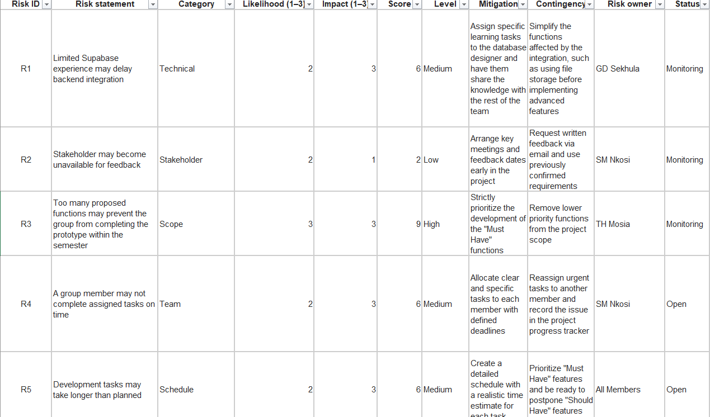

Picture2
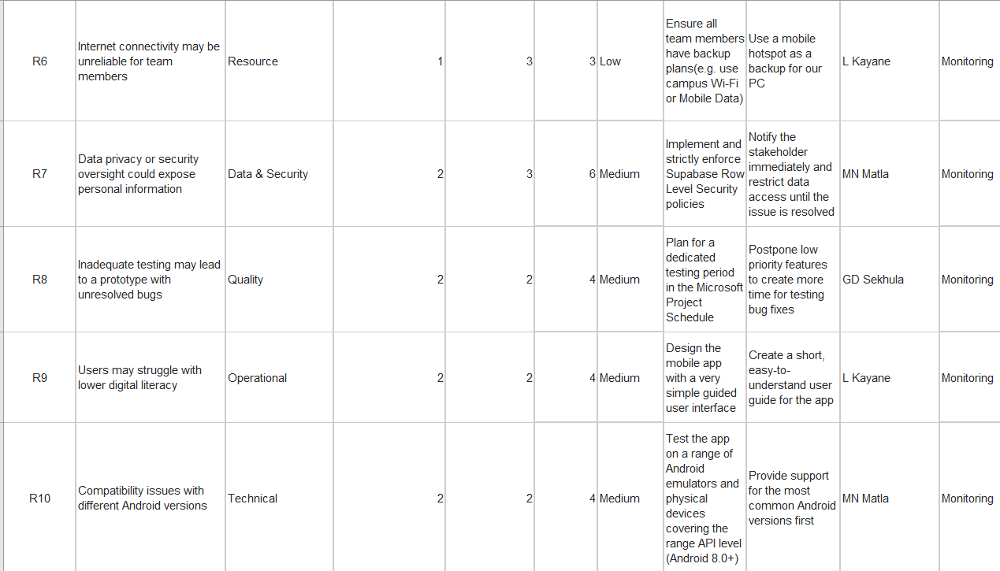

Highest Risks

Highest risk | Why is this important? | What must the group do now?
1. R3 - Too many proposed functions | If the team over-promises on features, they may end up with an unfinished product that doesn't meet the core 'Must Have' requirements. | The group must formally review the functional requirements and strictly prioritize 'Must Have' functions.
2. R1 - Limited Supabase experience | Supabase is the backbone of the system. | The group should immediately prioritize a "spike" or proof-of-concept to set up a basic Supabase project and connect both Flutter and ASP.NET applications to prove the concept works.
3. R4 - Group member may not complete assigned tasks | Threatens the project timeline. | The Project Lead should establish a clear and regular progress tracking system with brief daily stand-up meetings to monitor contributions and identify blockers early.

SWOT ANALYSIS: Lenyora Primary School Digital Application System

INTERNAL FACTORS
STRENGTHS | WEAKNESSES
Clear Stakeholder engagement: The group has secured a real external stakeholder (Lenyora Primary School) with a signed agreement and documented interview confirming the project's need.  Well-defined requirements: The SRS documents clear functional and non-functional requirements based on stakeholder interviews.  Modern technology stack: Flutter, ASP.NET Core, and Supabase are appropriate and well-suited to the project requirements.  Good group collaboration: The Project Progress Tracker shows all members contributed during Phase 1, with clear task division and resolved challenges.  Appropriate resources: All necessary development tools and test devices are available at no cost. | Tight schedule: One semester is available, but the group must learn new technologies while developing the prototype.  Limited project management experience: The group is still learning tools like Microsoft Project, which may affect planning accuracy.

EXTERNAL FACTORS
OPPORTUNITIES | THREATS
Real stakeholder need: The school faces genuine problems with paper-based processes and is eager for a digital solution.  Growing market for school digital solutions: Similar systems are increasingly adopted by schools, indicating demand.  Skill development: This project provides valuable practical experience with in-demand technologies. | Scope creep: The stakeholder may request additional features during development, threatening the schedule.  Technology changes: Updates to Flutter, ASP.NET Core, or Supabase could require additional learning or affect compatibility.  Infrastructure limitations: Parents may lack suitable Android devices or reliable internet, affecting adoption.

